**AFRL Research Collaboration Program**

**Contract FA8650-13-C-5800**

**Effect of Constituents and Microstructure on Energy Dissipation Mechanisms During Damage Growth**

**University: Texas A&M University**

**REPORT COVERS PERIOD: XXXXXX THRU 6-30-18**

Currently covers 4/1/17-3/31/18

1. **PROJECT TEAM MEMBERS**
2. **LEAD UNIVERSITY POC:** John Whitcomb, 979-845-4006, jdw@tamu.edu
3. **PROJECT TEAM MEMBERS:** John Whitcomb, Collin Blake
4. **AFRL TECHNICAL POC:** Craig Przybyla
5. **TECHNICAL DISCUSSION**
   1. **CURRENT WORK**

Development of the infrastructure to perform mesoscale analysis of 3D textile composites.

**Background**

Something about how the project started and what the ideals were behind the research.

**Approach**

Given by quarter. Not sure if you will want to re-order the document or not but Ive compiled everything thus far by quarter that I have access to.

**4/1/16-6/30/16**

This work compares the progression of damage using a continuum damage model and cohesive zone model. Both of these models have been used extensively in previous research. Continuum damage offers the benefits of allowing damage to occur anywhere, easier mesh generation, and better numerical stability. However, continuum damage does not directly model discrete cracks or fiber/matrix debonding. The use of cohesive elements alleviates this shortcoming, but the analyses have mesh dependency and much worse numerical stability.

During this quarter, the focal problem was an infinite hexagonal array of fibers subjected to uniaxial loads. Because of periodic boundary conditions, only one fiber was modeled. Figure 1 shows the finite element mesh. Uniaxial load was applied. The direction is defined by the angle theta. For this initial study, the properties were adjusted to match the strengths for the two models for theta= 0 deg.

**Figure 1: Visual Description of Method**

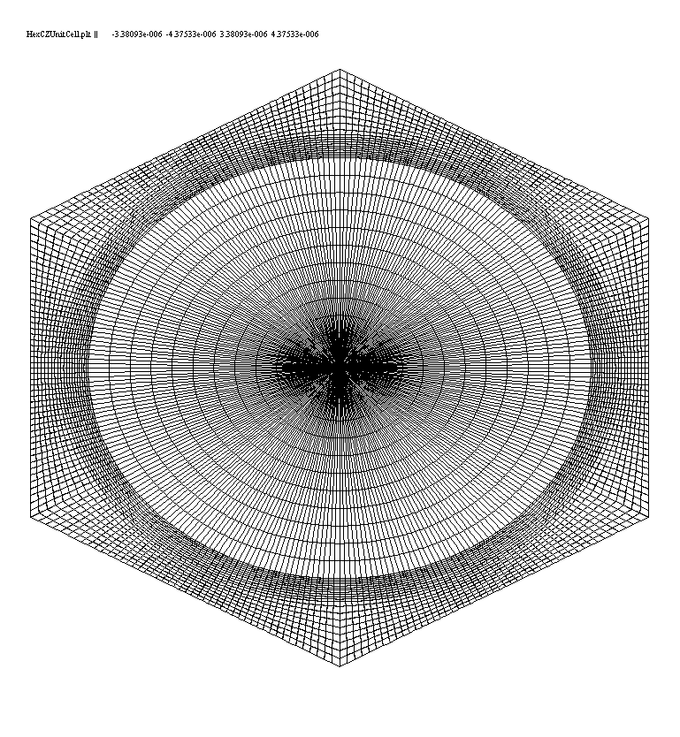

* Highly refined mesh
* Periodic boundary conditions imposed to create infinite array

❑

Direction of applied uniaxial load

**Continuum damage model**

Reduce moduli when strength exceeded

**Cohesive zone model**

Progressive opening per traction-separation law

As both the normal and transverse strength of the cohesive zones were adjusted by a percent reduction, the error between the continuum damage model strength and the cohesive zone model strength also reduced. Figure 2 shows the relative error per each reduction.

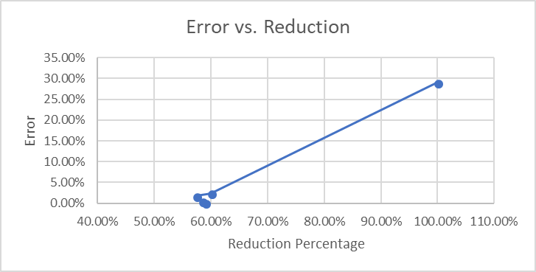

**Figure 2: Percent error as a function of percent reduction**

The relative strengths of each model can also be compared through this iterative process. Figure 3 shows the variation of strength for the cohesive zone model as it approaches the desired value from the continuum damage model.

A preliminary comparison of loading angle was also conducted with the adjusted cohesive zone strength parameters. Figure 4 shows this comparison between the two models.

**Figure 4: Model Strengths through angles of loading**

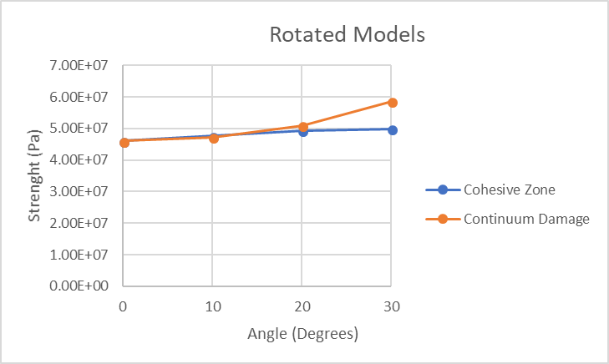

**Figure 3: Evolution of strength for the Cohesive zone model at 0 degrees**

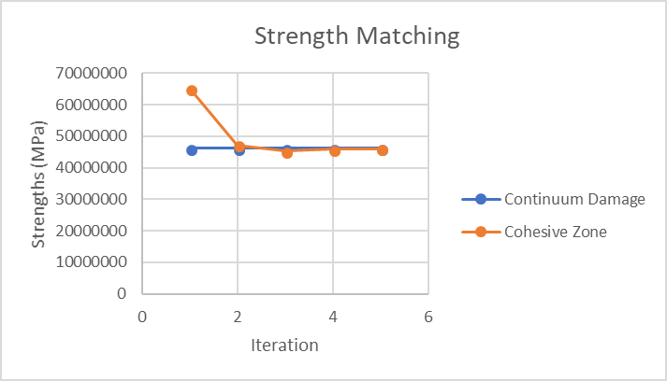

**7/1/16-9/30/16**

This work compares the progression of damage using a continuum damage model and cohesive zone model. Both of these models have been used extensively in previous research. Continuum damage offers the benefits of allowing damage to occur anywhere, easier mesh generation, and better numerical stability. However, continuum damage does not directly model discrete cracks or fiber/matrix debonding. The use of cohesive elements alleviates this shortcoming, but the analyses have mesh dependency and much worse numerical stability.

During this quarter, the focal problem was an infinite hexagonal array of fibers subjected to uniaxial loads. Because of periodic boundary conditions, only one fiber was modeled. Analysis of the dependence of the continuum damage model on the mesh refinement was conducted. Uniaxial load was applied. The direction is defined by the angle theta. For this study, the direction of the loading is at theta= 0 deg. The parameters for the mesh for the matrix is defined radially and circumferentially and were increased individually by factors of 2, resulting in overall refinements of 4. Each refinement was subjected to the same loading with the same properties. The strength and energy dissipated was determined for each analysis and analyzed for convergence.

**Figure 5: Progression of Mesh Refinement (5x6, 10x12, 20x24)**

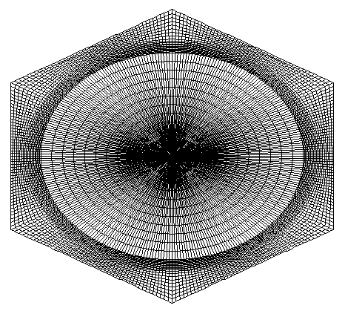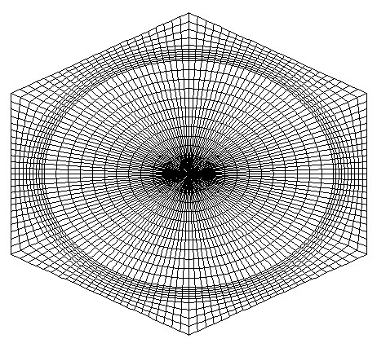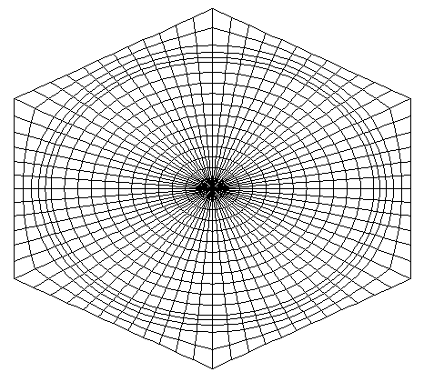

The initial refinement chosen was 5 radial elements (outwards) and 6 circumferential elements (from the axis of symmetry through each face). Figure 5 shows a progression of refinements with their parameters (radial x circumferential). As the refinement is increased, both the strength and the energy dissipated begin converging to their respective values, as can be seen in Figure 6.

**Figure 6: Strength and Energy Dissipated as functions of Refinement Factor**

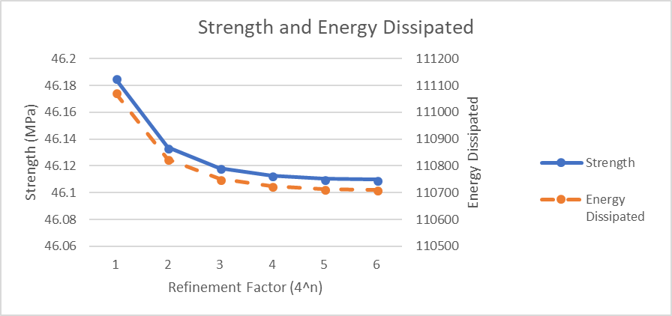

Figure 6 shows fairly similar convergence rates for both values. Note that the values on the vertical axis are very close, indicating that even a very coarse mesh has very similar values compared to the more refined meshes. The energy dissipated is affected by mesh refinement. A coarser mesh has the ability to hold a small amount of load after the initial failure. As each load step is applied more energy can be released due to this phenomenon. Therefore, the energy dissipated is calculated assuming full model failure after the first load step. Figure 7 shows the differences in the energy dissipated using the two calculations. Note, Figure 6 uses the second method for energy dissipation.

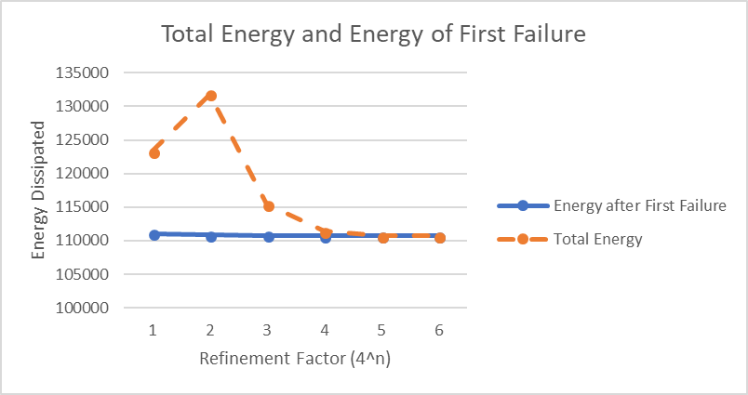

**Figure 7: Energy of First Failure and Total Energy versus Refinement Factor**

Figure 8 shows the log base 10 of the relative errors of both the strength and energy dissipated compared to the log base 10 of refinement.

**Figure 8: Relative Errors of Strength and Energy Dissipated versus Increasing Refinement**

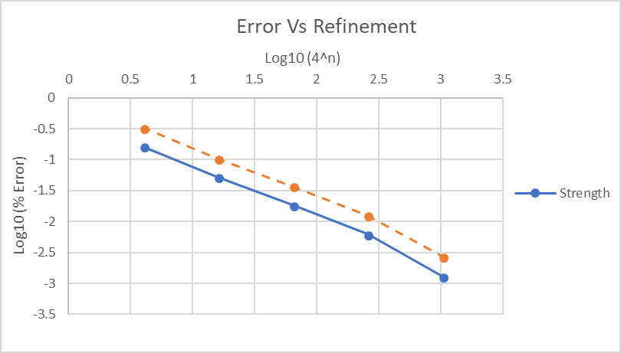

Figure 8 shows a nearly perfect linear convergence rate for both the strength and energy dissipated. This rate can be used to predict the values both metrics are converging to.

**10/1/16-12/31/16**

This work compares the progression of damage using a continuum damage model and cohesive zone model. Both of these models have been used extensively in previous research. Continuum damage offers the benefits of allowing damage to occur anywhere, easier mesh generation, and better numerical stability. However, continuum damage does not directly model discrete cracks or fiber/matrix debonding. The use of cohesive elements alleviates this shortcoming, but the analyses have mesh dependency and much worse numerical stability.

During this quarter, the focal problem was an infinite hexagonal array of fibers subjected to uniaxial loads. Because of periodic boundary conditions, only one fiber was modeled. The study examined the dependence of damage propagation on structured quadrilateral and unstructured triangular cohesive zone meshes. Uniaxial, horizontal load was applied. The refinement for the mesh for the structured matrix is defined radially and circumferentially and was increased by factors of 2 in each direction, resulting in overall increased element numbers of 4x. The unstructured meshes were parameterized by the number nodes along each hexagonal edge to match the structured meshes. These unstructured meshes were also randomly seeded to generate similarly refined meshes that were different geometrically. Figure 9 shows the same section of a mesh that has the same refinement but is seeded differently.

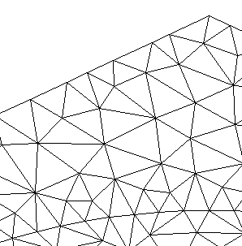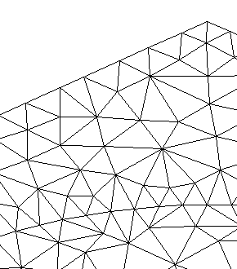

**Figure 9: Same Refinement, Different Seeded Section of Unstructured Mesh**



Figure 10 shows typical meshes. The fiber region of theses models are assumed to not damage and therefore are treated as fully elastic. Therefore, the refinement of the fiber is not as crucial as long as the stress gradients can be accounted for at the fiber-matrix boundary. Both meshes have a similar number of elements in the matrix that are similar in area and size. This allows for the same relative refinement but different geometry and element type. These meshes were used to determine the dependence of damage growth on mesh geometry specifically. Models for each refinement were subjected to the same loading with the same properties, including cohesive zone properties that simulate more brittle behavior. The strength and energy dissipated were determined for each analysis and analyzed for convergence and disparities.

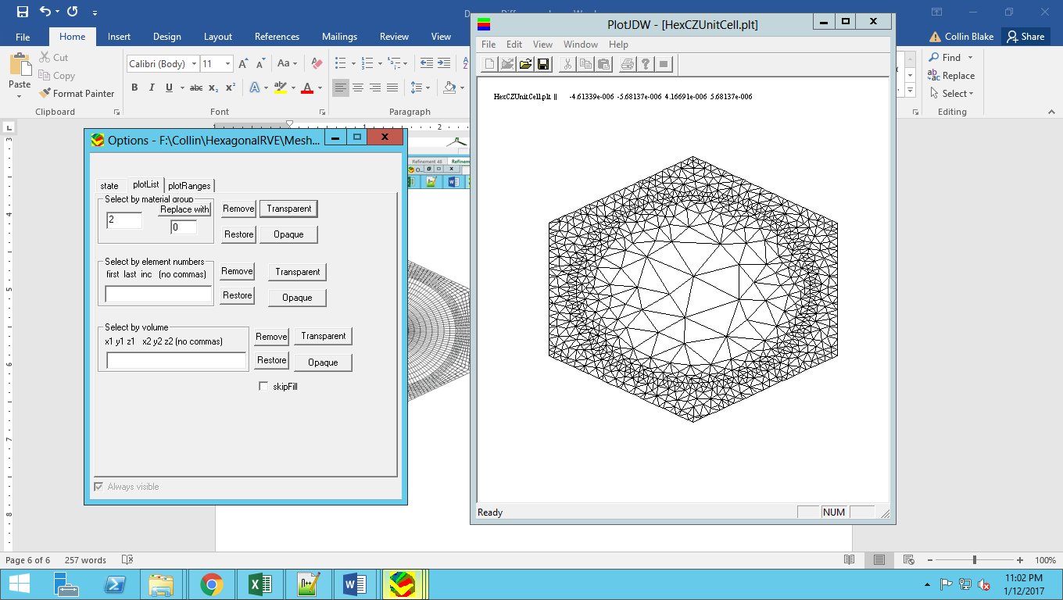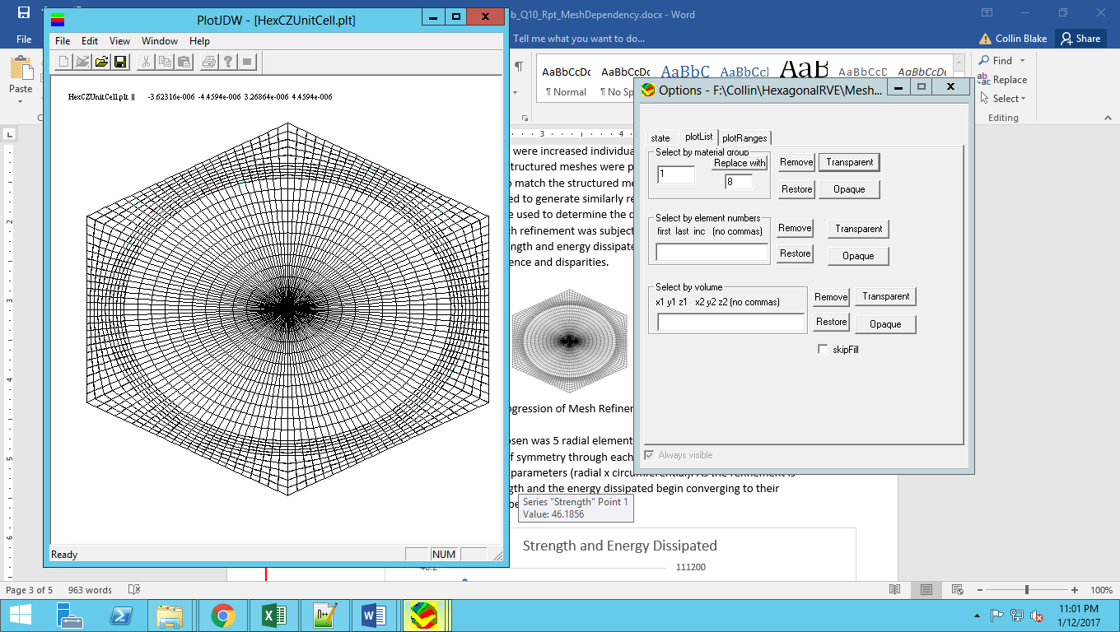

**Figure 10: Unstructured (Left) and Structured (Right) Meshes (Refinement 24)**

After the initial analysis, we found that there were inconsistencies in the strength predictions. We adjusted the load step increment from 0.1% strain per load step to 0.008% strain per load step. This reduced the differences between the strengths for the randomized unstructured meshes. However, there was still a large difference between the structured meshes and unstructured meshes in terms of strengths and energy dissipated, which we calculated by finding the area underneath the stress strain curve up to the peak stress. We assume that the failure is brittle and that the model could not hold any stress after the peak load. These differences were most prominent at high level of refinements. Figure 11 shows the stress-strain curves at the highest refined mesh (96 nodes along an edge).

**Figure 11: Stress-Strain Curve at Refinement 96 for all Meshes**

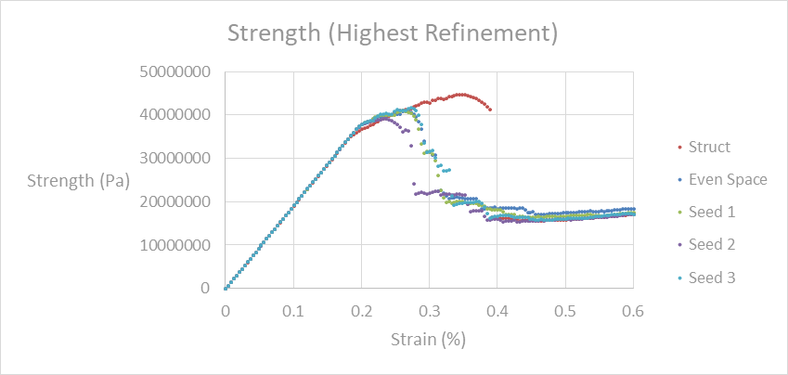

These curves show that the structured mesh has significantly more ductile behavior than the unstructured mesh using the same material properties. This forced us to look into the damage patterns produced initially at the peak stress. The patterns found are shown in Figure 12. For the structured mesh, there was no damage right at the fiber/matrix interface. For the unstructures mesh, the most intense damage still occurred a short distance from the interface, but there was also damage between the fiber and the location of the intense damage.

Figure 12 shows noticeably different damage patterns for the same amount of strain. The lines and green areas outside the fiber are the damaged cohesive zones between the elements. In Figure 12, the undamaged matrix elements have been hidden to better show these damaged areas. While the damage is relatively in the same area, the damage patterns are different. The structured mesh damage pattern shows parallel but unconnected cracks. The unstructured mesh shows one large crack with multiple, partially connected matrix cracks, which we believe is more realistic. This leads us to believe that the arrangement of elements may have a larger effect on the models than originally anticipated. It appears that the structured mesh with quadrilateral elements is not allowing a similar pattern of damage that is allowed by triangular elements of the unstructured mesh. It is unclear at this point if the element shape is the source of the differences, or if the element type contributes to this discrepancy as well, and further study of this behavior is needed for a definitive conclusion.

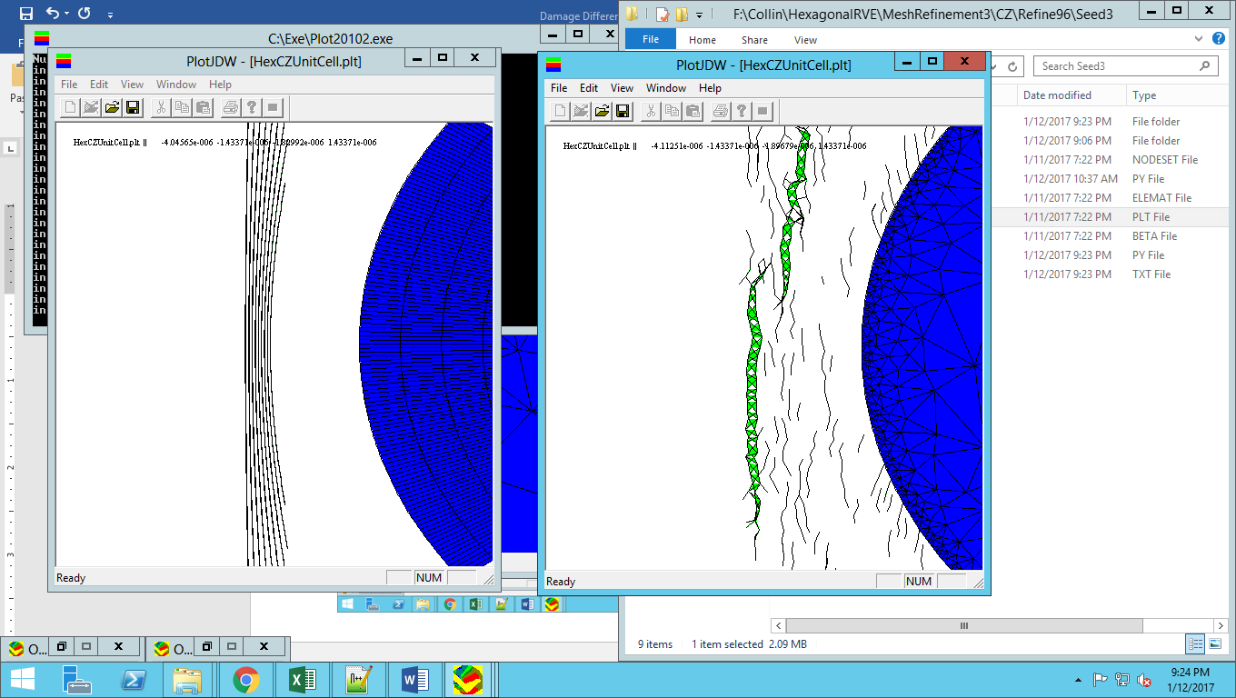

**Figure 12: Damage Propagation at Equal Load Step, Structured (Left) and Unstructured (right)**

**1/1/17-3/30/17**

Collin learned the basic process that VTMS uses to generate its geometries. VTMS creates this geometry by starting with an idealized approximation of fiber weave pattern. This approximation is then “fiberized” into smaller domains, which are then relaxed into a textile shape. Once the shape is clipped to an appropriate size, it is then converted to a surface geometry. The results of this process are shown in Figure 13.

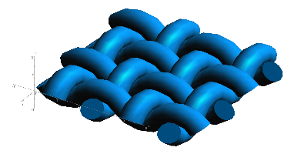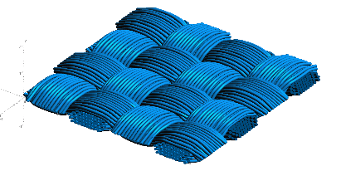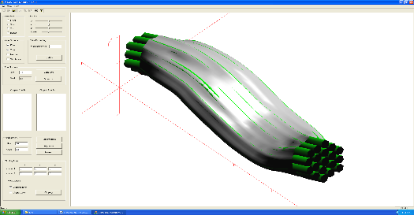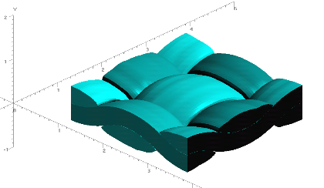

**Figure 13: Evolution of Weave Tow Geometry**

**a) Generic Approximation of Woven Pattern**

**b) Filament Representation of Pattern**

**c) Surface Approximation of Filament Bundles**

**d) Volume Model Derived from Surfaces**

The process to produce these geometries is quite difficult. The relaxation process requires hundreds of “relaxation steps” that frequently result in the interpenetration of fibers, rendering the model useless. The relaxation itself requires constant monitoring and adjustment of factors, boundary conditions, and tension values that all affect the outcome. Sometimes the relaxation process becomes unstable. These instabilities can be fixed with some single-minded focus on these issues. VTMS is an impressive tool that we believe could benefit from further, focused development.

The geometries modeled are not without faults either. There have been multiple instances of interpenetrations of the tows that cause analysis difficulties after the fibers are made into a surface. The current solution is to shrink the tows until interpenetrations are removed. However, a more realistic, long term solution to this issue is desired and will be a point of focus in the coming months. If the issues related to relaxation and interpenetrations can be resolved, VTMS will be much more useful to the textile research community.

VTMS has its own mesh generation method, but it results in incompatible meshes that must be solved using the independent mesh method. Instead, we decided to create compatible meshes using the geometry resulting from VTMS. A large amount of time is spent on meshing these geometries. Geometries this complex require very robust meshing algorithms. Much of this quarter was spent researching and evaluating possible software to mesh these complex geometries with much less user intervention.

The first task was to evaluate a number of mesh generation programs to evaluate their potential for 3-D mesh generation. We are looking for software that can generate tetrahedral, quadrilateral, or hybrid meshes from geometry polygon data. If needed we can develop our own conversion scripts to the desired input of the software, but the mesh generation ability must be able to handle complex 3-D models. The following summarizes the evaluation.

Cubit/Trelis

This software suite is highly capable and complete. It comes with its own pre- and post- processing routines. However, it is under a costly license that is currently not sustainable under the current funding. Also, it has the same ability as the top candidate software (which is discussed later) but has a more polished user interface.

CGAL

This software is a collection of low-level routines and algorithms that require some development to run together. Currently some routines are being used within our own meshing routines. However, some of the newer routines could prove beneficial. CGAL is a backup to the more high-level commands we wish to use.

Gmsh

Based on previous experience with this software, the input files required are not conducive to complex geometries and require plugins for specific geometry files to be meshed. If a plugin were developed this software could also be useful, however we wish to avoid development time in this area if possible.

Abaqus

This highly used software suite has a very good scripting interface that makes meshing geometries very easy. However, an Abaqus license is required to run the software along with development to convert VTMS geometry into Abaqus geometry. This is also another option in case the primary software does not work out.

NetGen

This software is the primary software that we are pursuing. It is open source and still being developed by its designers, which means support is still available. It is also primarily written in C++, which helps in debugging and inclusion into our research code. Currently we are working on implementing its functionality on the scripting side instead of using its user interface. The next step will be to convert the VTMS geometry into NetGen’s preferred format.

**4/1/17-6/30/17**

During this quarter, time was spent both at Texas A&M and AFRL. While at Texas A&M, VTMS was further explored so that he could further efforts in using this software for research. Also, another similar type of software, call DFMA, was explored. This software is developed by a research group from Kansas State University. Eric Zhou was a member of his group during his time at Kansas State. This exploration of DFMA lead to a deeper understanding of the input parameters that is used by VTMS as both software use a derivative of the digital chain method. From this new understanding, a process similar to that in Figure 1 can be conducted on a complex geometry like in Figure 14.

Figure 13.d shows a volume representation of a collection of filament bundles derived from a surface representation shown in Figure 13.c. It is at this step that interpenetrations between the surfaces appears.

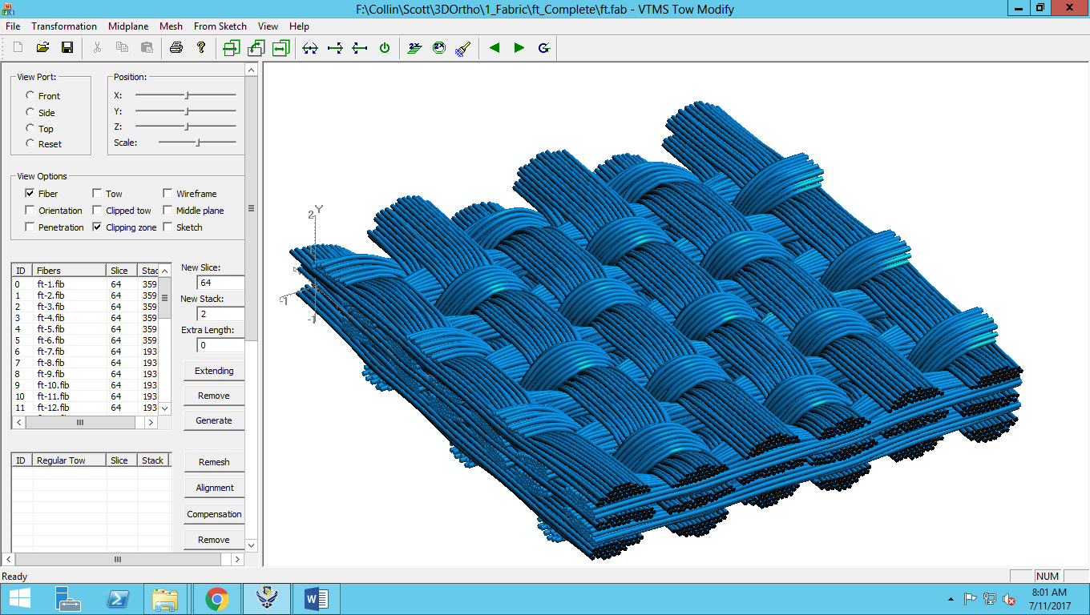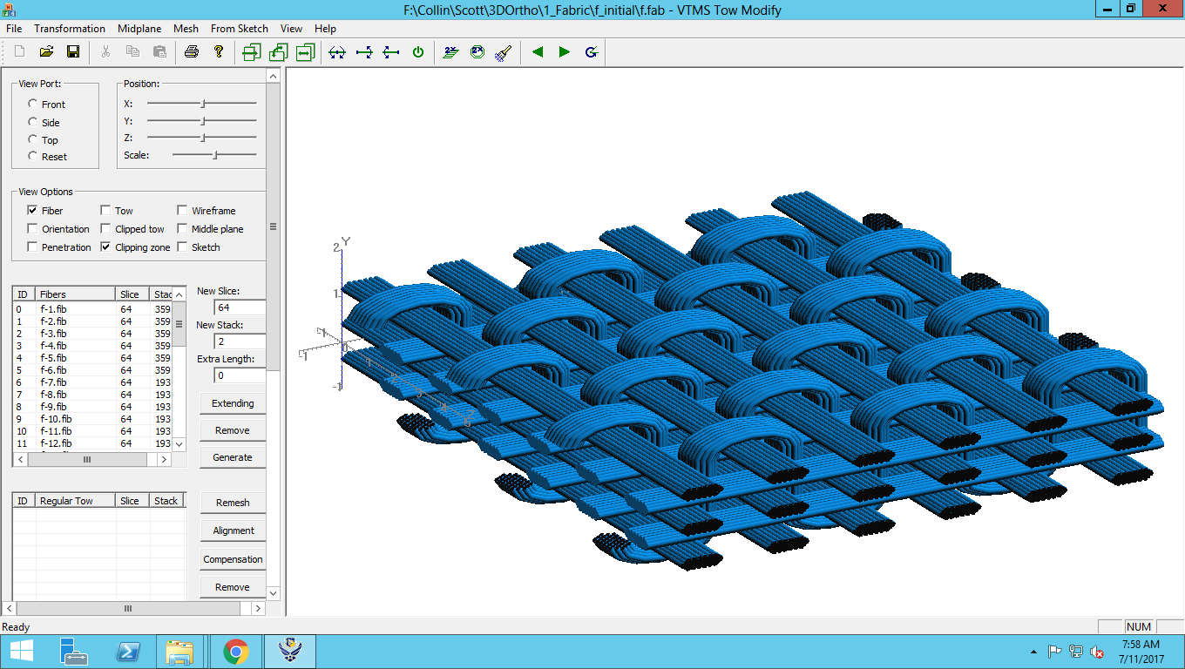

**Figure 14: Preliminary-to-Post Relaxation of Complex Fabric Geometry**

While at AFRL, Collin Blake explored the inner workings of VTMS while allowed access of the software code. Here, he gained even further understanding of how VTMS works and why the interpenetrations occur. He also discovered the method by which the software attempts to solve the interpenetrations on its own.

**7/1/17-9/30/17**

The surface fits (shown in Figure 13.c) result in regions of overlapping surfaces, which causes significant issues in meshing these models. These surfaces are defined by nodes that are connected in a fashion similar to a mesh. These surface nodes can be determined as penetrating another surface geometry by a method inside of VTMS. The focus of the last quarter has been to resolve penetrations between surface definitions of the textile geometry.

**Figure 15: Rough Sketch of Penetration Phenomena**

Figure 15 shows a representation of a series of penetrations between two geometries, one running in the plane of the page, the other running out of the page. Illustrated are multiple regions that need to be resolved.

The first attempt at a solution was to define a plane that represents a contact surface between the geometries. This surface could then be used as a domain to resolve a penetrated region. This plane could also be used to define a compatible mesh between the two geometries for an analysis. Unfortunately, this method could not be adapted for multiple regions of penetrations, as illustrated in Figure 15 above. This is due to the relatively large curvature of certain geometries along with the three-dimensional nature of the models. **More info here?**

The second method developed was a routine that paired penetrating nodes between the two surfaces by determining which nodes were in closest proximity. The routine then assigned both nodes to the halfway point between their original locations. This routine easily solved compatibility and solve the penetration regions. However, this solution was not robust for the case of single node penetration regions and resulted in some models having a significant change in surface geometry, as seen in Figure 16. **More info?**

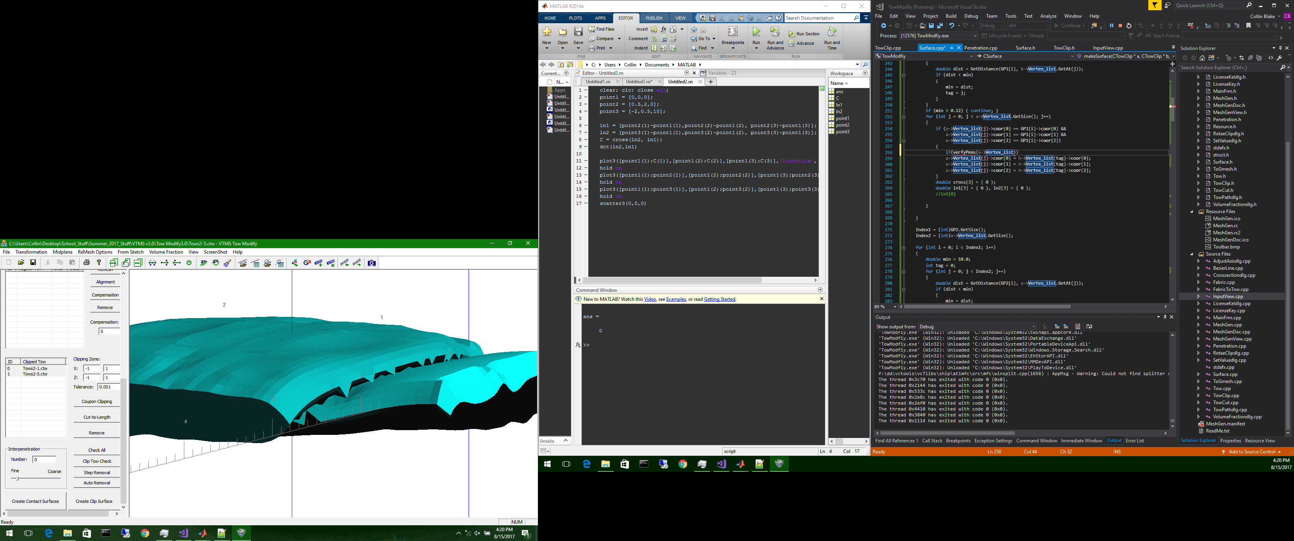

**Figure 16: Two Surfaces with Significant Boundary Changes Before (Left) and After (Right) Routine**

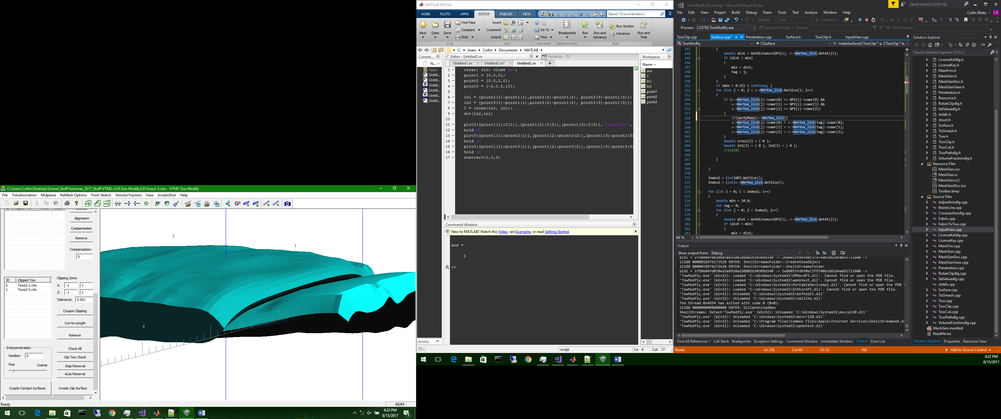

After further investigation, it became apparent that the penetration detection routine in VTMS was not entirely accurate for certain geometries. This discovery lead into a need for a method that could cover both aspects of the problem. Our efforts were focused on the implementation and use of a Non-Uniform Rational B-Spline (NURBS) surface algorithm written by the Geometry Group at SINTEF ICT, Department of Applied Mathematics. A NURBS surface is an analytical representation of a surface that can be evaluated at any point on the surface. The representation can be fitted to existing data points in three dimensions. It will allow us to determine an intersection curve that accurately describes the region of penetrations. NURBS also detects single node penetrations which can be difficult to find and resolve. We are now able to fit a surface for a geometry (Figure 17) and detect full regions of penetrations (Figure 18).

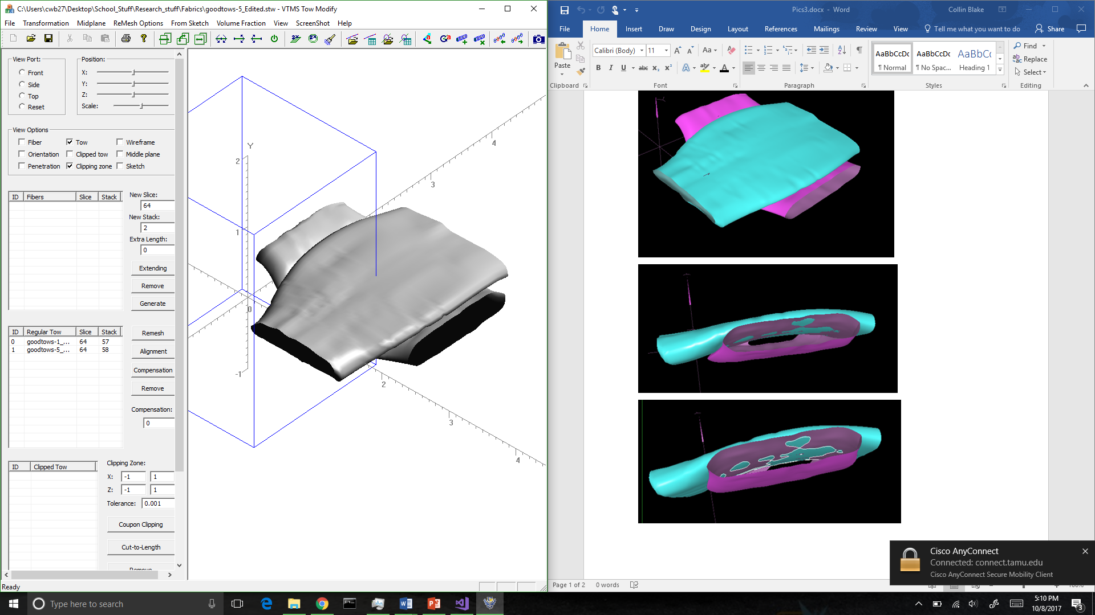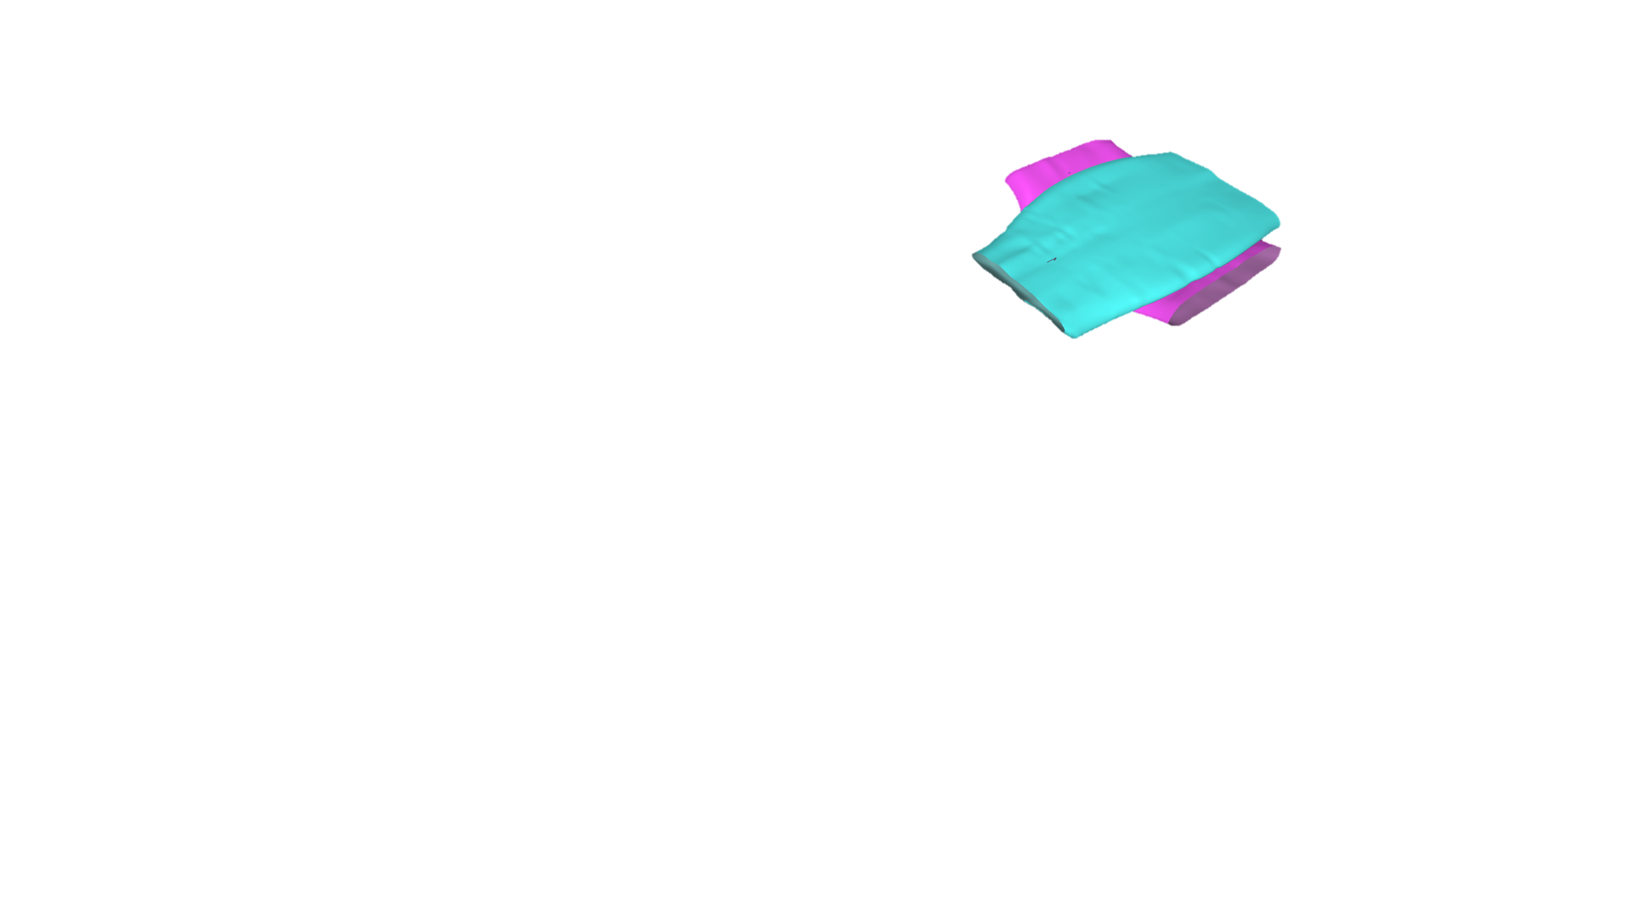

**Figure 17: VTMS Surface (Left) and a NURBS Representation (Left) of the Same Surfaces**

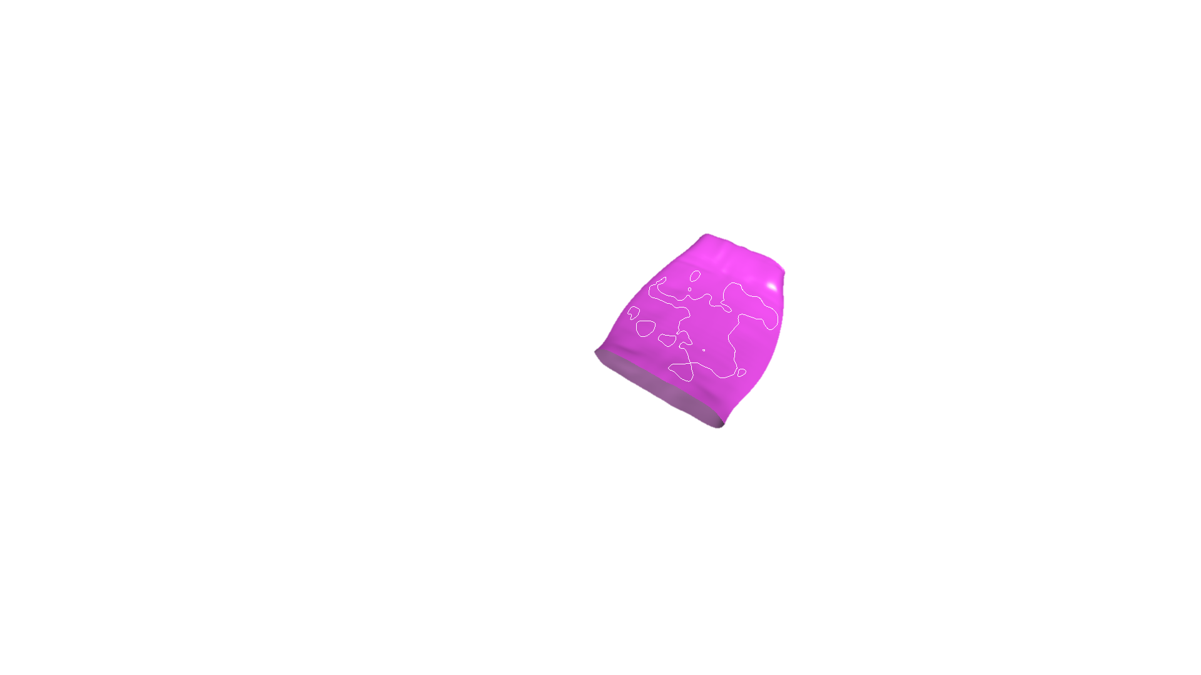

**Figure 18: Surface with Penetrating Regions Outlined in White**

This method showed much more promise for detecting and resolving penetrations in these models.

**10/1/17-12/30/17**

We had been depending on the viewer supplied by the SISL library to view the NURBS representation and intersection curves. It became apparent that a more powerful viewing program was needed. Therefore, we developed a way translate the data so that the viewer ParaView could be used. This allows us to show node, control point, and element numbers for tracking specifics of the problem areas.

**Figure 19: Illustration of Penetration Phenomena REPLACE FOR FIGURE 3?**

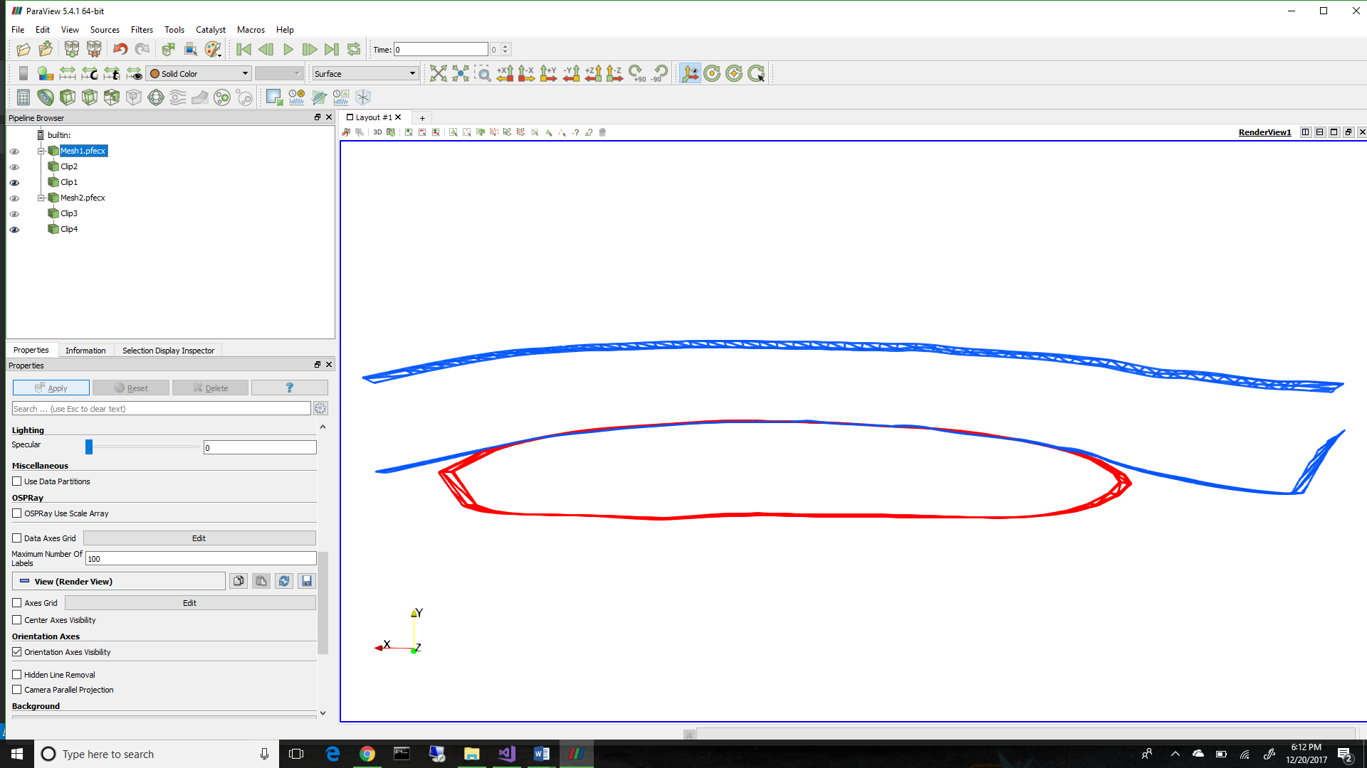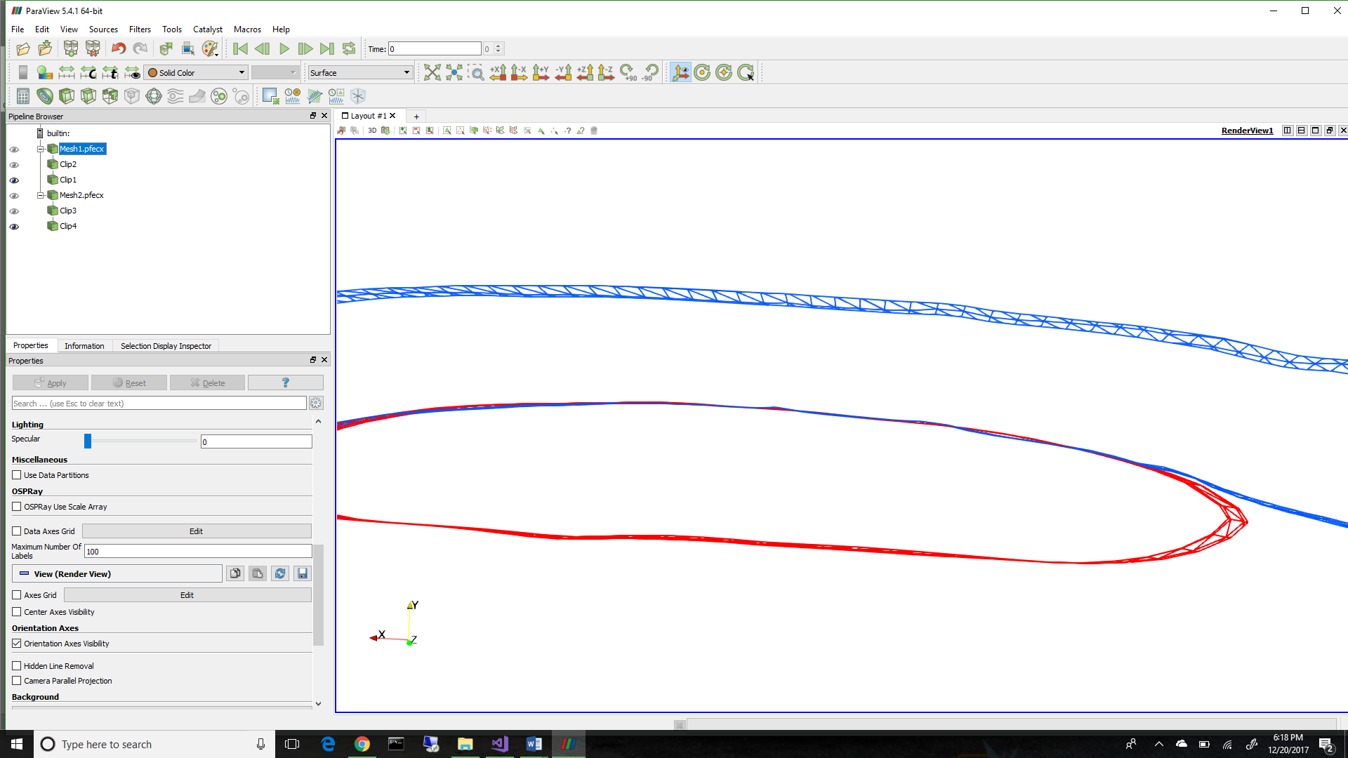

The next problem to be solved is how to visualize the intersection curves within ParaView. The method for identifying the penetration regions returns a curve that lies on the intersection between the two surfaces. From this curve, we can identify the points that describe the curve and use them to describe the curve in ParaView. To do this, we connect each pair of points with a linear, two node element, and generate a “mesh” of the nodes. This allows us to identify each curve separately.

FIGURE?

We can also use all of our previously developed mesh manipulation algorithms on these curves to do different operations we may find necessary. The results of translating intersection curves and NURBS approximations can be see below in Figure 20. To display the surface representation, there are two methods that can be used. The first is to simply use the point data supplied by VTMS and connect them by triangular elements to create a surface mesh. The other is to take the NURBS surface and evaluate the surface on an evenly spaced grid in the two parametric directions. This method will give us a more accurate method in displaying the NURBS surface over simply using the control points that describe the surface. This is also what the SISL library uses to evaluate the intersection between the two surfaces. The result of the two representations can be seen below in Figure 21. The blue surface is the VTMS data/control points and the red is the evaluated NURBS surface. You can see that they are very similar but not exact, which is expected. The difference between the two is minimal, however we have no metric as of yet to determine how much of a difference exists. A good metric to measure the difference in the two would be the volume occupied by each geometry.

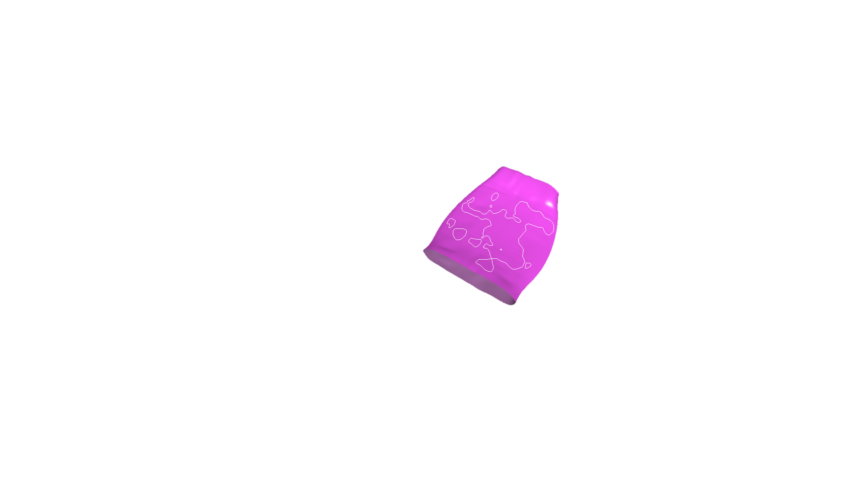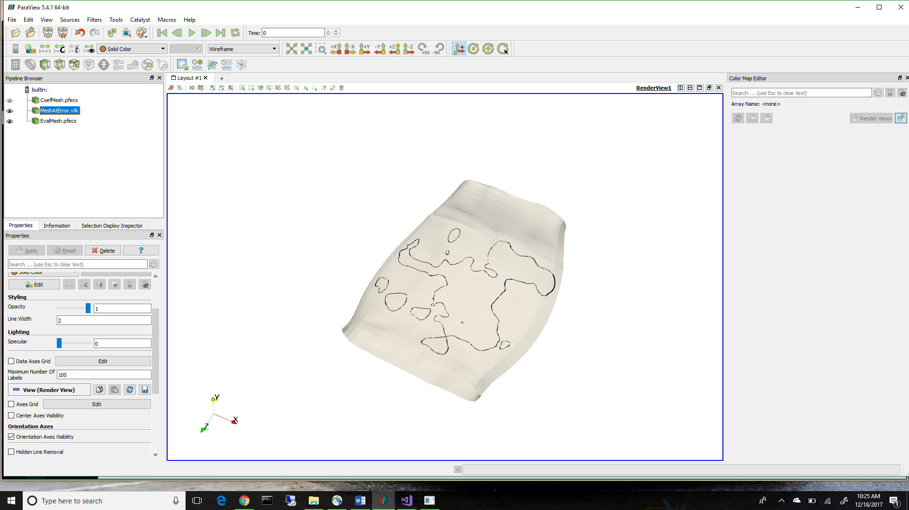

**Figure 20: ParaVeiw vs. SISL viewer of Translated Data**

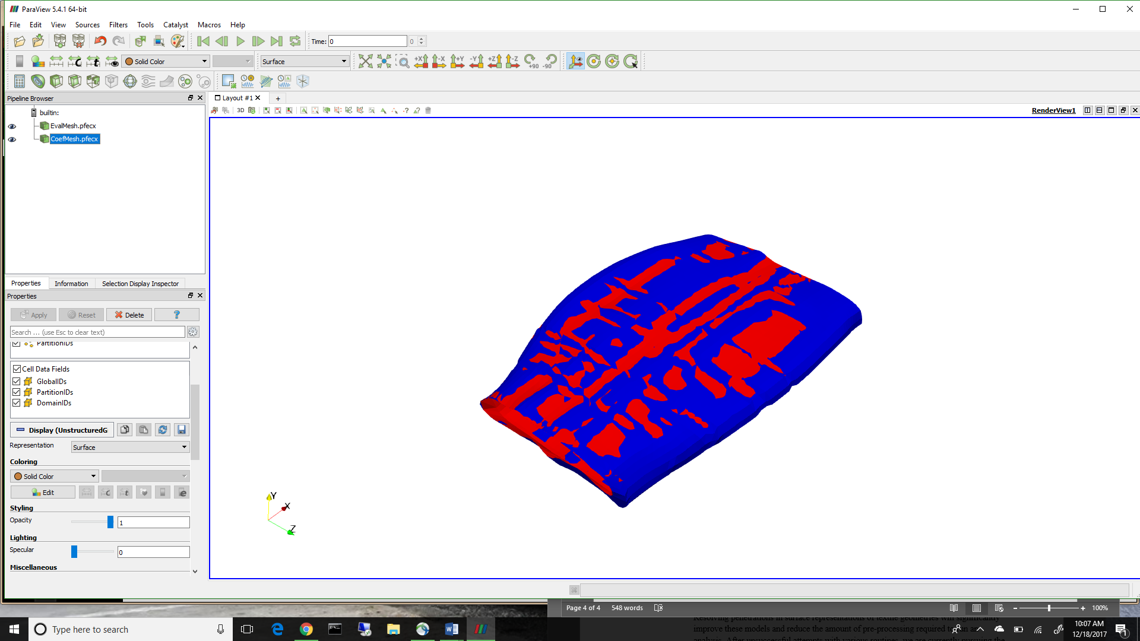

**Figure 21: A Comparison of NURBS surface and VTMS Data**

**1/1/18-3/31/18**

The regions returned from the library are described by multiple boundary curves that are not guaranteed to be unique or closed. The curves can remain open and overlap. Therefore, an algorithm was developed to test the curves against each other in order to consolidate any curves that overlap. The algorithm also removes curves that are duplicates. The impact of this step is not readily visualized, since the goal is to have the same regions identified, but with a cleaned up description of the regions. **More info?**

A decision had to be made on what is needed to create a compatible mesh between the two tows where they overlap. The curve needs to have nodes where the curve itself intersects elements on the surface of each tow. Also, knowing which elements have been intersected by the interpenetration region boundary curves is useful in sub-meshing the intersected elements. The surface mesh and boundary curve interactions can be seen in Figure 10.

[Grab your reader’s attention with a great quote from the document or use this space to emphasize a key point. To place this text box anywhere on the page, just drag it.]

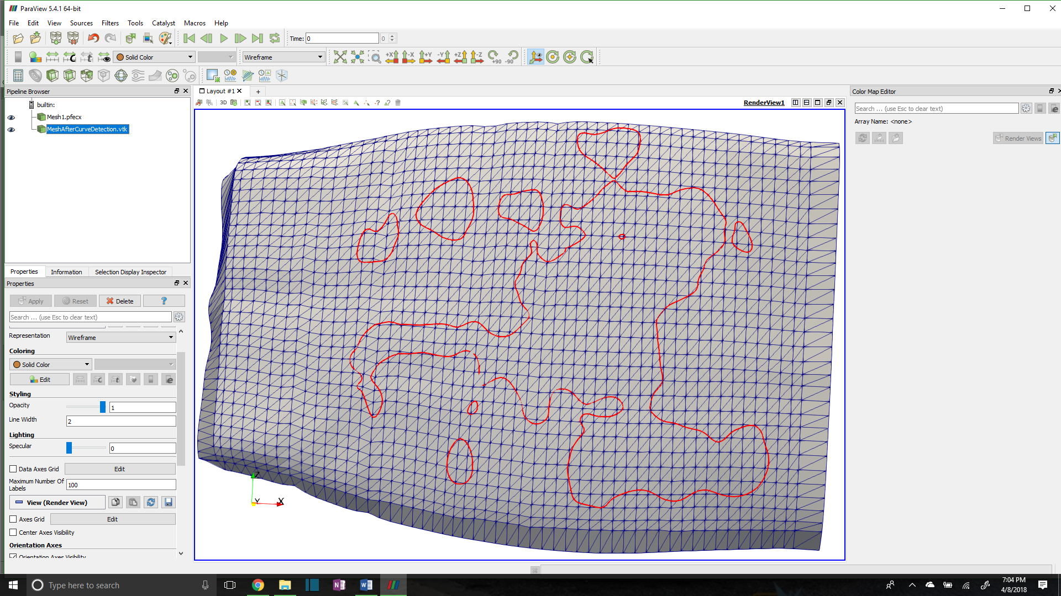

**Figure 10: Interpenetration boundary curve with tow surface mesh**

To identify which elements are intersected, and to refine the boundary curve where it intersects surface elements, the Separating Axis Theorem (SAT)**[1]** is implemented. The SAT starts by projecting the polygons onto axes. The projection can be thought of as the shadow of the polygon on an axis. The axes are created by taking the normal direction of an edge and creating an imaginary infinite line in the same direction. Figure 11 shows a projection of a triangle onto the red axis (RA) that is determined by the red edge (RE) and is parallel to the red edge normal (REN). The line segment along RA (labeled “Triangle Projection” is the projection of the triangle onto the axis RA in Figure 11. Three axes are identified, one corresponding to each side of the triangle.

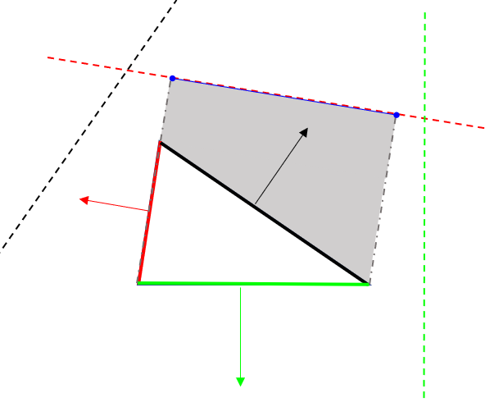

**Figure 11: Projection of a triangle on an axis**

**RA**

**REN**

**RE**

**Triangle Projection**

**[1] Method was found on website resource (**[**http://www.dyn4j.org/2010/01/sat/**](http://www.dyn4j.org/2010/01/sat/)**) as part of a game collision engine blog. Theory developed by Hermann Minkowski as Hyperplane Separation Theory**

Next, the projections are tested to see if they overlap. If there is an axis on which the projections do not overlap, then the polygons do not intersect. If the projections overlap on every axis, then the polygons do intersect. A reference picture is shown in Figure 12.

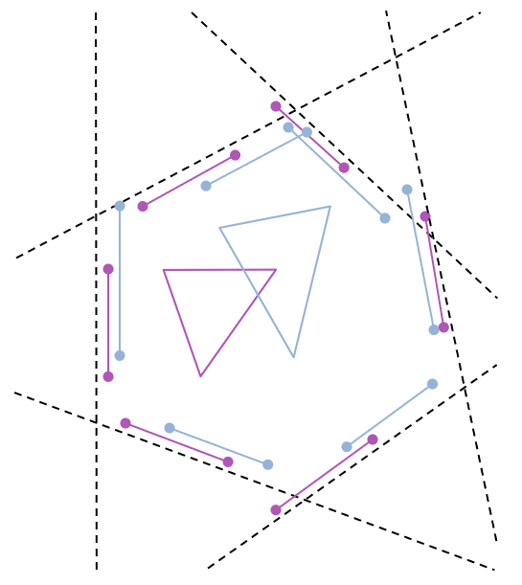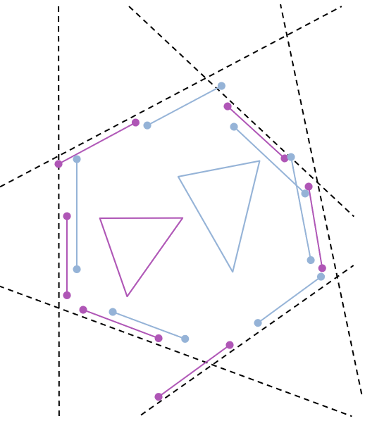

**a) SAT in which triangles overlap**

**b) SAT in which triangles do not overlap**

**Figure 12: Two cases for testing the Separating Axis Theorem**

In Figure 12.a), two triangles are shown to intersect. This can be verified by looking at each dotted line that represents a projection axis. Along each axis the bounds of the triangles are shown. There is no axis in which the bounds do not overlap. Figure 12.b) shows the case when the two shapes do not intersect. The axes (dotted lines) are the same in 12.a) and 12.b), since the orientations of the two triangles are the same, only the positioning is different. Circled are boundaries that do not overlap in 12.b) and therefore verify that the triangles do not intersect.

Once the intersected elements are identified, we determined which boundary curve segments intersect the edge of a tow surface element, create a node at which the segment and edge intersect, and add this node to the boundary curve. An example is shown in Figure 13 where the original nodes were the endpoints of the two line segments.

We employ this algorithm for every intersection along both tows and their elements. This results in a boundary curve that is compatible with the two surface meshes where they intersect each other. This gives the information needed to enforce compatibility between the two surfaces.

The next step it to re-mesh the elements that have been intersected so that the shape of the curve can be captured within the surface mesh of both of the tows. This requires the intersected elements identified earlier. After we sub-mesh each individual element on both tows, we can add them back to the original mesh. The result is shown in Figure 14 and 15. Figure 14 shows only one boundary curve sub-meshed and appears as a thick blue line due to the refinement of the elements around the curve. The red lines show the remaining boundary curves that have yet to be sub-meshed in this figure.

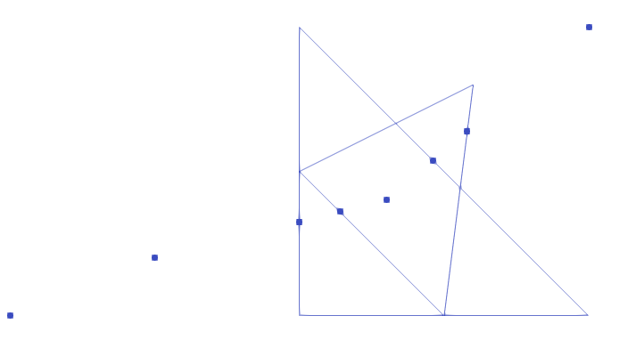

**Figure 13: Boundary Segments Intersecting an Element from each Tow**

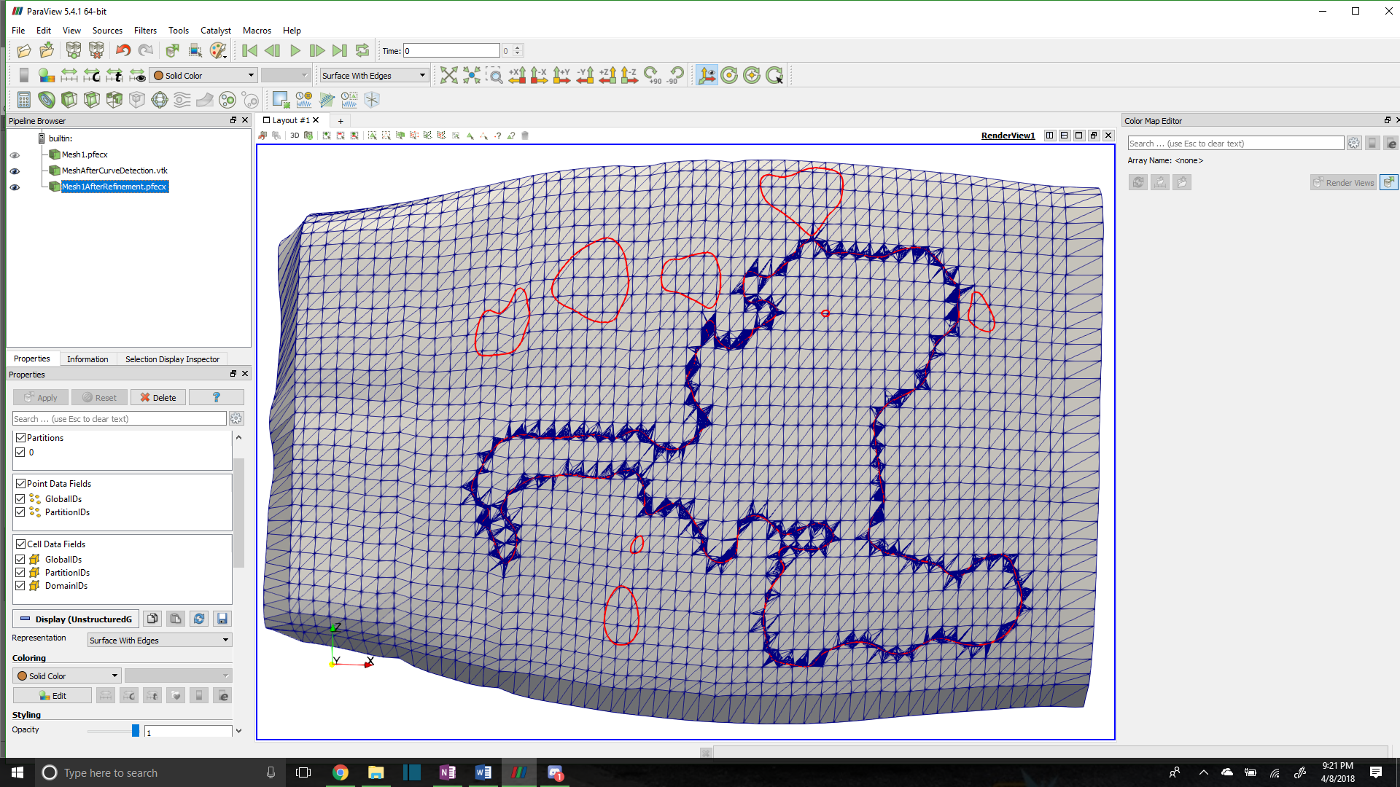

**Figure 14: Tow Surface Mesh with One Boundary Curve Meshed**

Figure 15 shows some problem elements. The problem with some of these elements are their high aspect ratio. This can adversely affect an analysis in which they are used and can produce incorrect results.

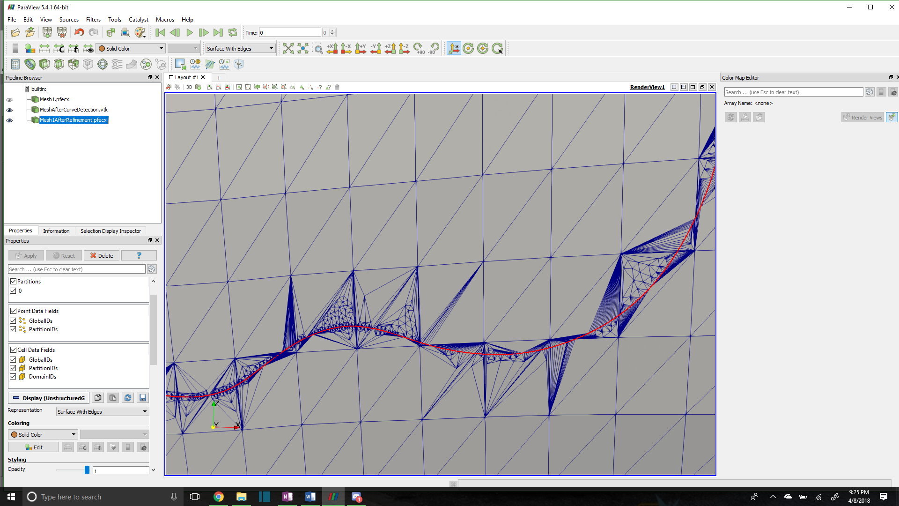The method to fix this is to record which nodes are added to the boundary curves due to intersections with surface elements and remove most of the boundary curve points that lie between any two element intersection nodes. This solution potentially loses some of the features of the boundary curve but will ensure that the tows no longer penetrate in the boundary curve regions. The result can be seen in Figures 16 and 17.

**Figure 16: Reduced Refinement Meshed Intersection Boundary Curve**

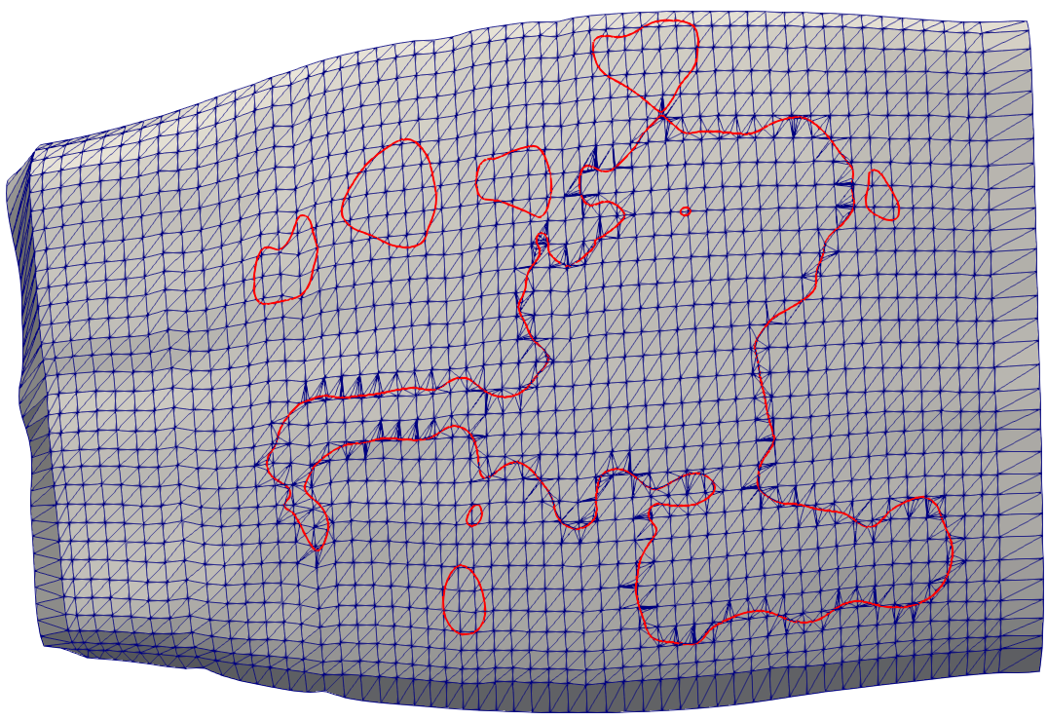

**Figure 15: Close Up View of Refinement**

**Figure 17: Up-close View of Reduced Refinement**

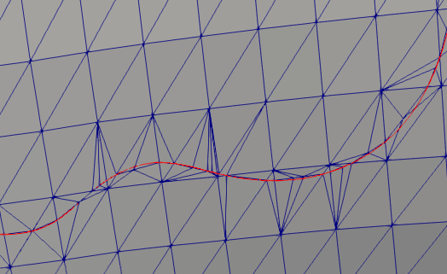

Figures 15 and 17 can be compared as they are the same section of boundary curve. The number of high aspect ratio elements is significantly reduced. However, there is still some evidence that these elements exist. The arise from when the boundary curve is too close to the corner of an element. Our solution is to implement an algorithm that when this situation is identified, the corner node will be moved to the boundary curve, essentially removing the interpenetration and enforcing compatibility in the same step.

**We hope to add this fix before the due date of the report. Keith has also mentioned he has an algorithm written to collect the elements inside of the boundary curves so I will hopefully implement that as well before the deadline. Therefore the conclusion may change as well.**

* 1. **CONCLUSIONS/ANALYSIS TO DATE**

Interpenetrations regions between surface representations can be identified. The basis for identifying these regions is a NURBS library that can represent VTMS data as a NURBS surface and then identify the regions of interpenetrations by creating a boundary curve. Multiple methods for visualizing both the surfaces of the tow and the boundary curve of the interpenetration regions have also been developed. A low-refinement interpenetration boundary curve that is conducive to meshing can obtained. This curve can then be used to sub-mesh the tow surface mesh, enforcing compatibility between the two intersecting tows. While there are still some problem elements, a solution is being implemented to fix the scenario that causes these elements.